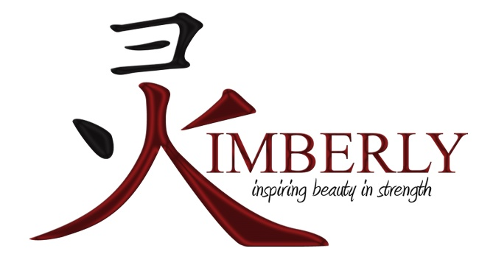
4/12/19 Shirley M. Rodgers e-Girls Summit Empowering Girls in Real Life Situations ~ Sponsored by Michigan Department of Transportation ~ Kimberly’s Workshop Topic: Healthy vs. Toxic Relationships
2/19/19 Women’s Heart & Soul ~ Sponsored by AARP MI & The Lansing/E. Lansing Links Kimberly was invited to share and serve as a wellness vendor during this inspiring event.
12/1/18 Kimberly's 3rd Annual Holiday Health & Wellness Open House
11/12/18 Potter Walsh Neighborhood Association "Annual Meeting Speaker"
9/22/18 Pilgrim Rest Baptist Church "Women's Conference" - Youth Workshop Facilitator
​7/30/18 Modern Woodmen Fraternal Financial "Courage Builds Confidence"
4/17/18 Pilgrim Rest Baptist Church "School of Discipleship" - Get Fit Series Presentation & Workout
3/26/18 Living an Inspired Life Series "Building Positive Habits" at Delta Township Library
3/12/18 Living an Inspired Life Series "Imagining Your Best Self" at Delta Township Library
1/31/18 Coffee & Visit with Kimberly at Iorio's Gelateria
1/10/18 Coffee & Visit with Kimberly at Iorio's Gelateria
12/6/17 Keynote Speaker for Michigan Department of Transportation ~ On-The-Job Training Summit Mt. Pleasant, MI
12/3/17 Holiday Pop-Up at Iorio's Gelato & Caffe
11/25/17 Kimberly Inspiring Beauty in Strength Presents ~ 2nd Annual Health & Wellness Open House
11/18/17 Walk of Ages ~ 1 Year Anniversary Walk
10/9/17 Sister's in Strength ~ Woman's Life Chapter
9/8/17 Sparrow Foundation & Women Working Wonders (W3) 43rd Annual Kaleidoscope
6/29/17 Michigan State Capitol Steps ~ Keynote Speaker for Michigan Dept. of Transportation YDMP
​5/20/17 Josephine Brown Women's Missionary Society ~ Motivating Spiritual & Healthy Christians
3/11/17 Jack & Jill Of America, Inc. ~ Midwestern Region Michigan Children's Cluster
​2/15/17 Lansing Community College - 2nd Annual Black Business Expo (Black History Month)
1/28/17 St. Stephens Community Church - Women's Weekend Unlimited Power
​10/24/16 ZONTA International - Career Educational Days - J.W. Sexton H.S. Math Science & Engineering
9/9/16 Sparrow Foundation & Women Working Wonders (W3) 42nd Annual Kaleidoscope Women’s Fitness: Listening to Your Internal Drum
8/1/16 Delta Township District Library - Living Healthy: Easy Fitness Tips
6/30/16 Alpha Kappa Alpha Sorority, Inc. - The Longest Day - Exercise for All Ages (Group Fitness)
5/28/16 Grace Bible Baptist Fellowship - Annual Ladies Tea
5/21/16 Better Health Market (East) Workshop on Kimberly's 3 Approaches to Well-being
12/15/15 State Bar of MI - Finance & Administration - Division Retreat
11/14/15 Better Health Market (West) - Health & Wellness Seminar

